CS 305 Module Five Coding Assignment Checksum Verification Template

Instructions
Using the instructions from the Module Five Coding Assignment Checksum Verification Guidelines and Rubric, replace the bracketed text with the relevant information in your own words.

Algorithm Cipher

I would recommend SHA-256 (Secure Hash Algorithm 256-bit) to generate a checksum that verifies the integrity of the company's public key. SHA-256 belongs to the SHA-2 family of cryptographic hash algorithms and is supported in Java through the java.security.MessageDigest class using the algorithm name "SHA-256" (Oracle, 2017). SHA-256 creates a 256-bit hash value, which is always 64 characters long when shown as a hexadecimal string. It is a good choice because it is very hard to find two different inputs that produce the same hash value. This provides strong protection against collisions. (Manico & Detlefsen, 2014). This helps detect changes to a downloaded public key. SHA-256 is a hashing algorithm, not an encryption cipher, making it suitable for checksum generation and data integrity verification.

Justification

SHA-256 creates a unique hash value for each input. If you change the input, even a little bit, the hash will almost always be different. Collision resistance matters because an attacker should not be able to create a malicious file that produces the same hash as the original (NIST, n.d.).
SHA-256 is a better choice than older algorithms like MD5 and SHA-1 because researchers have shown that these older algorithms can be compromised. It's important to stop using SHA-1 and to switch to stronger options from the SHA-2 or SHA-3 families (NIST, 2022). Using SHA-256 helps clients verify that the downloaded public key matches the expected data. A checksum alone does not guarantee authenticity if an attacker can replace both the file and its checksum. A trusted distribution channel or digital signature provides stronger protection.

Generate Checksum

You’ll submit your refactored code to your instructor. Your instructor will review it and this document.

VerificationInsert a screenshot below of the web browser with your unique information.

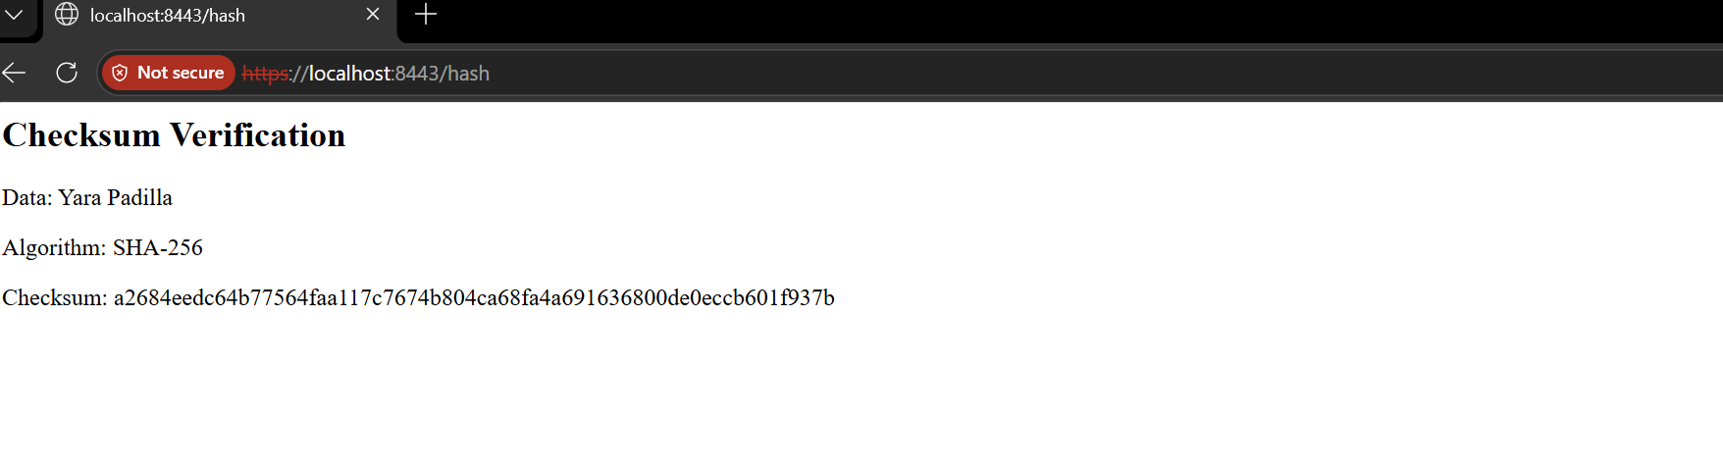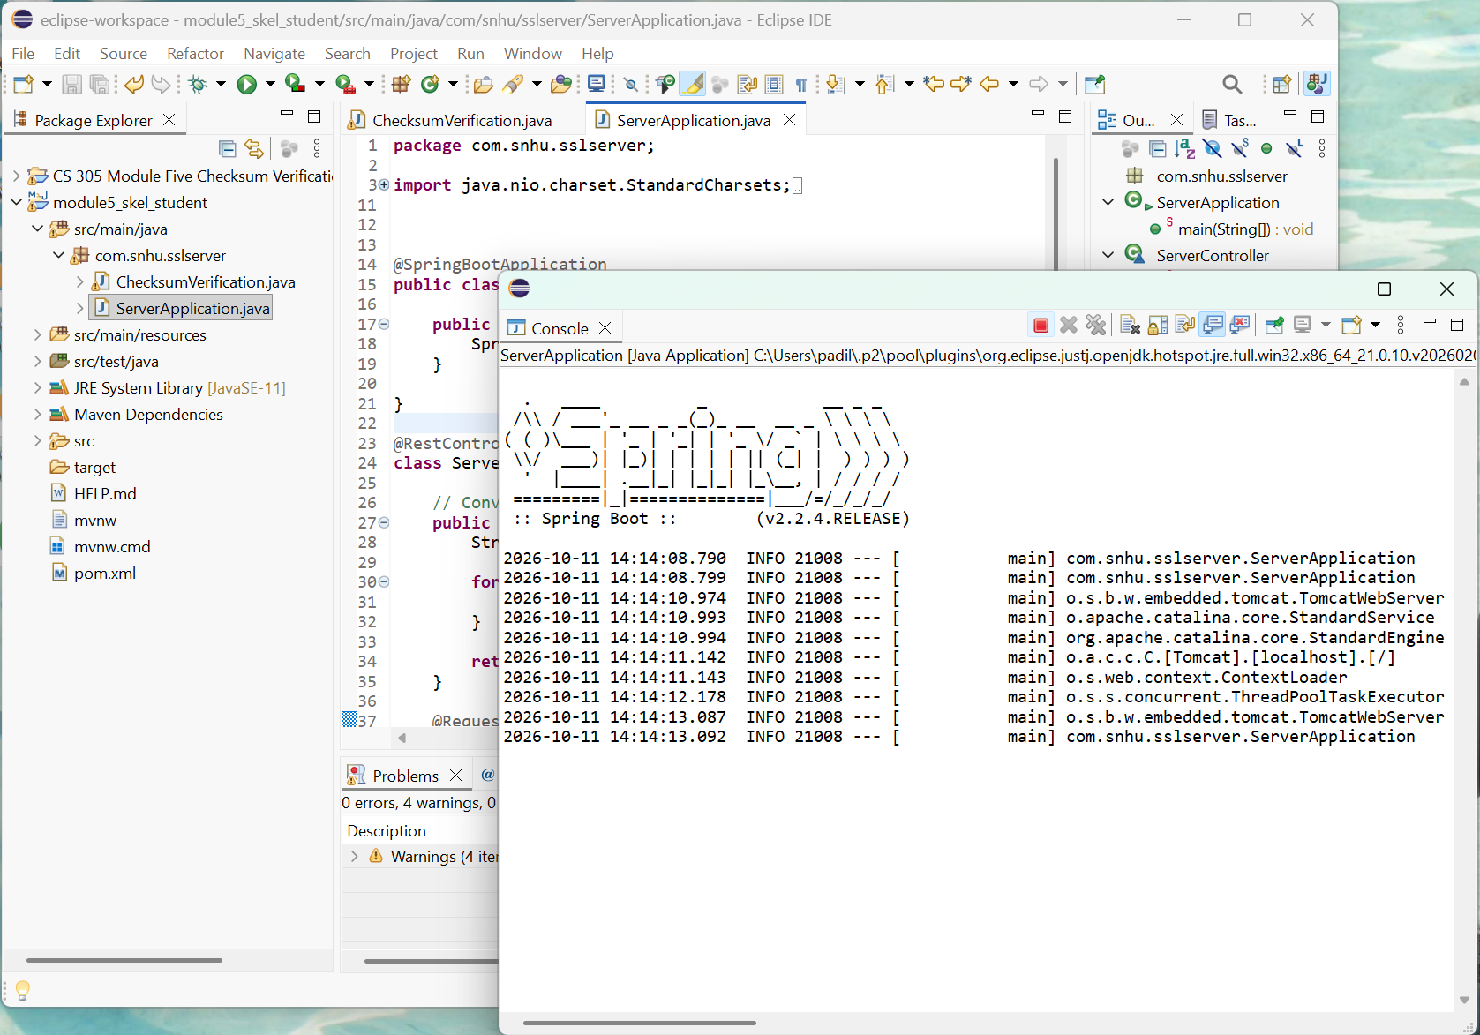

References:
Manico, J., & Detlefsen, A. (2014). Iron-clad Java. McGraw-Hill Education.
National Institute of Standards and Technology. (n.d.). Hash functions. https://csrc.nist.gov/projects/hash-functions/nist-policy-on-hash-functions
National Institute of Standards and Technology. (2022, December 15). NIST transitioning away from SHA-1 for all applications. https://www.nist.gov/news-events/news/2022/12/nist-transitioning-away-sha-1-all-applications
Oracle. (2017). Java security standard algorithm names. Java Platform, Standard Edition 9. https://docs.oracle.com/javase/9/docs/specs/security/standard-names.html#cipher-algorithm-names

